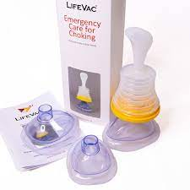
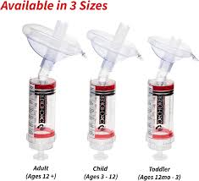

The De-choker to use or not?

A few months ago at one of our Conversation & Catchup sessions we talked about De-Chokers, are they any good? Should we buy one? Having done some extensive research I am going to try to put it in perspective for you.
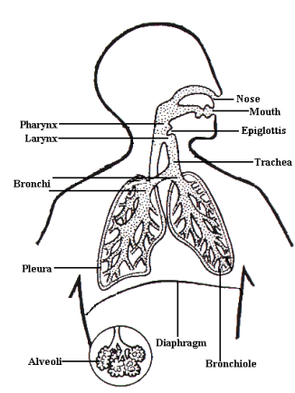
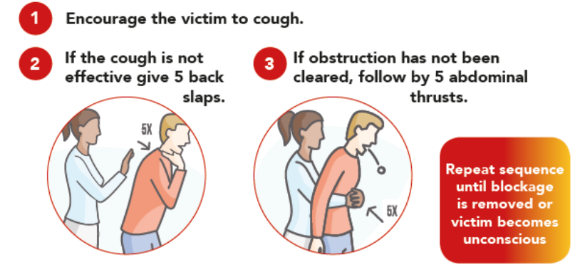
We have all choked on food or drink that has ‘gone down the wrong way’, it’s why we’re told as children don’t eat with your mouth full? Sit up properly and hold your head up when eating and drinking! Common sense advice to stop us choking. Food tends to get stuck where the cross is placed. This is where the brain senses food is touching the airway and forces the epiglottis to close.

The current guidelines are as shown here above with the following additions;
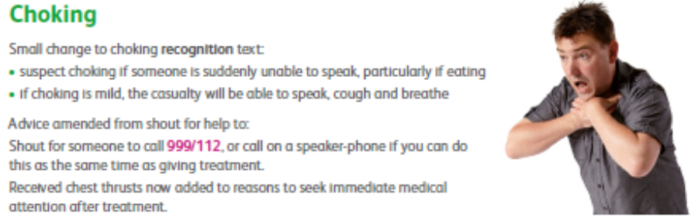
UK 2021 guidelines state
that if abdominal or chest
Thrusts have been given
seek Immediate medical
attention after treatment

UK Resuscitation Guidelines 2021 gives us this algorithm;
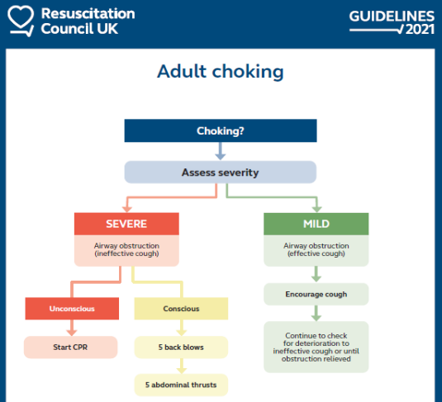
Guidelines published by De-choker
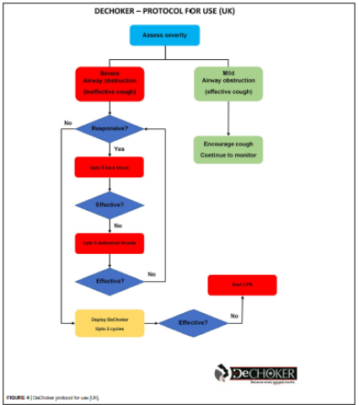

Back in 1990 I qualified as a First Aid Trainer and with regards to choking not much has changed from then to the latest guidelines in 2021 as you can see. 5 back slaps between the shoulder blades with the person leant forward, 5 Abdominal thrusts (Heimlich manoeuvre as it was known then), and repeat. If the person collapsed in those days you did rescue breaths to blow the object into a lung with the object then being removed in hospital, (shows how much we have moved forward?). Then you did CPR which in 1990 was 2 rescue breaths and 15 chest compressions. Now in 2021 CPR is 30 chest compressions & 2 rescue breaths (if trained to do rescue breaths, as a health care professional we should be able to do rescue breaths.) The current situation with Covid 19 is that we should at least be doing chest compressions/thrusts, but if we are trained to use a defibrillator we will be trained to do CPR with rescue breaths.
Statistics
In 2021 following a freedom of information request from Life Vac (one of the companies selling de-chokers) showed that 12 NHS Ambulance trusts attended 26,594 call outs due to choking/FBAO in 2021 at a cost of £6,701,688.
This is 73 people a day and that does not account for those who clear the obstruction themselves by coughing or are helped with back slaps and/or abdominal thrusts.
4 out of 12 NHS Ambulance trusts reported that 211 casualties were DOA due to choking/FBAO in total. If we use 211 DOA, then the total DOA due to choking for all 12 NHS Ambulance Trusts for 2021 would be 633.
In the last 5 years there have been at least 14 cases of death by choking in care settings, recorded by coroner’s courts in the UK. In all 14 they were as a result of failings by staff to protect the residents.
A paper published in 2020 by Innovation and Research, Northamptonshire Healthcare NHS Foundation Trust, Berrywood Hospital, Northampton, United Kingdom stated; Professional Concerns
Since De-Choker was introduced to the UK in 2017 awareness of the product has grown amongst health and care professionals. Discussions have taken place within these communities of practice, with professionals seeking advice from colleagues and
their professional bodies. The Resuscitation Council UK issued a statement regarding the generic use of ACD devices in the UK.
“There is insufficient evidence on the safety or effectiveness of these devices for us to recommend their use, and we are concerned that the use of these devices could delay established treatments for choking; the Council therefore does not support their use.”
The conclusion of the document states; A choking emergency is traumatic and distressing for victims and health care staff alike; however the treatment and supporting evidence base for the management of the adult choking victim has developed little over the last few decades. The risks associated with administering the current interventions for the management of the adult choking victim for patients and staff, are recognized. ACD application might improve the safety of management,
particularly within a growing elderly population. De-Choker is an innovative product that is available for use within the care home sector.
The evidence from this evaluation demonstrated that it is being used effectively and safely in emergency choking situations where recommended management methods have failed or cannot be implemented. It appears to be valued as an adjunct resource by the care home staff that used it. Training on the De-Choker device was seen as adequate, but could be further strengthened by regular refreshers and role play scenarios as used in other Basic Life Support training. Clearer guidance is required for health and care professionals around the resuscitation of the elderly or immobile patient. Specific guidance for the resuscitation of this population does not exist, but the issues are recognized by those that care for them. This should include guidance on the management of dentures, bariatric, wheelchair, and bedbound patients.
Further evaluation and research would be beneficial to develop a more robust evidence base that can support ACD adoption into resuscitation guidelines.
Staff Training:
All staff members must have training based on the Care Certificate, and further training as required. This includes First Aid, Medication Awareness & Administration, Nutrition & Hydration, Physical & Mental Conditions Awareness.
Causes of choking – ask yourself? | Staff Training required
Medical condition  Do they have a medical condition which affects eating and drinking?  e.g. Stroke, Diabetes, Cancer, Dementia, Allergies etc | First Aid & specific training in the condition, & how it affects eating and drinking.
Position of person  Are they sat up and supported?  If not are they at least at 45 degrees and supported?  Can they hold their head up? | How to support a person to eat and drink, moving and assisting to move a person.
Extract from coroners reports
- “a gross failure” of neglect.. he was only to be fed small, soft foods.. Paramedics retrieved five pieces of cauliflower from 2cm to 5cm in size from his mouth.
- The woman, who had been assessed as at risk of choking, was on a specialist diet and should have not been given the doughnut,
Causes of choking – ask yourself? | Staff Training required
Physical condition  Can they eat and drink unaided?  Do they have a sore mouth?  Do they have properly fitted dentures?  Can they swallow effectively?  Do they have a tracheostomy, colostomy, ileostomy, urostomy or catheter, NG tube or PEG/PEJ? | Nutrition & hydration training, mouth care, caring for stoma’s.  Training from SALT teams, dentists etc where appropriate.  Training from stoma nurses where appropriate.  Use of appropriate diet e.g. soft, liquid etc.
Mental condition  Do they have the ability to understand how to eat and drink safely? | Mental health awareness with regards to eating and drinking.
Medication  Does their medication affect how they eat and drink? | Medication administration where this could or will affect eating and drinking.

All training should be done annually or more often if a new member of staff or a new person being supported or if a person’s condition changes. Any person who has had an episode of choking must; be checked by medical professionals and care plans updated as necessary.
Extract from coroners reports
- daily handover sheet identified his risk of choking and that he needed assistance in cutting up his food but did not explain requirements for monitoring or that food should be cut up into small pieces.. he was given his lunch and left alone. Shortly afterwards he was found unresponsive in his room. Paramedics were called and removed an approximately 2 inch by 1 inch piece of meat from his throat.

I could go on but all the cases I researched found a lack of training, supervision and support to be at the base of all the deaths. As to the original question ‘should we have a de-choker, or similar on the premises? The official UK Resus Guidelines don’t have them in and the next change in guidelines is not due till 2026. The Council does not recommend them.
But at the bottom of all this is the basic precept: STAFF MUST BE TRAINED REGULARLY IN FIRST AID and if you do choose to buy this piece of equipment, STAFF MUST HAVE MORE REGULAR TRAINING IN ITS USE, it is like AED’s, we hope we never have to use them, but we must train regularly, and be confident they will work. At the end of the day it’s use would come between abdominal thrusts & chest thrusts on the algorithm and even if successful the person would still need to be checked at hospital.
So clear as mud? My personal point of view is as follows, update first aid training annually for all staff, AED training every 6 months and ACD training if you choose to buy one every 3 months, but,
KEEP PEOPLE SAFE, LEARN, EVERY SINGLE DAY.
Written by; Linda Dixon Forget Me Not Care Training Support Ltd
UK Resuscitation Guidelines 2021
https://www.resus.org.uk/library/2021-resuscitation-guidelines
Life Vac information https://www.lifevac.uk/2022/04/14/
Nursing Times Clinical Zone https://clinicalskills.nursingtimes.net/

